Rohit Yadav  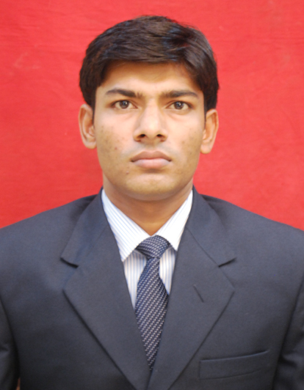  - Email :  Rohityadav533@gmail.com  Mob. No- 09811286348  Present Address:  C-1, Durga complex ,  Madanpur khader  Sarita vihar,New Delhi-86  Permanent Address:  - Vill: Khawasbari  - Po: Purani Basti  - Dis: Basti  - State: U.P (India)  - Pin: 272002  Personal Snippet:  - Father's Name: Mr. Sukhram Yadav  - Date of Birth: 16th April 1991  - Sex: Male  - Nationality: Indian  - Marital Status: Single  - Languages: English, Hindi | - Carrier objective:  “An enthusiastic & confident person, having tremendous capabilities to handle the task of the organization by using proper skills & talent so that prior objectives of the organization could be achieved & proving as an asset for the organization.”  - Long term:  To become a successful Manager and contribute to the best of my  Potential.  - Work Experience:  Organization : Kotak Mahindra Bank Ltd. From Oct2014to till now..  Designation : Deputy Manager  Key Result Areas :-  - Maintaining Relationship with the existing client.  - Relationship management and solving problem of  Mapped customer.  - Acquisition of fresh saving and Current account.  - Cross selling of the financial products like Equity, FD, MF  and Insurance etc by meeting customers.  Organization : ICICI Securities Ltd. From Sept 2012 to Oct 2014.  Designation : Relationship Manager  Key Result Areas :-  Meeting Client’s Financial Need, Coordinating with Team, Achieving Targets and Generating Revenue for the Organization.  - Meeting with the HNI Client.  - To analyze client financial need and sell the product according to the need.  - Meeting targets & prepare report on daily basis.  - Generating revenue for the organization.  - Providing all kinds of financial services to the Customers.  Working under a team and coordinating with seniors and colleague.  - Working Skills:  Developing Relationship, responsible, team player, result oriented, wide outlook, thirst of new learning, and patience to deal with client in the market.  - Academic Credentials:  - Post Graduate Diploma in Management (PGDM) from Master School Of Management, Meerut 2012 with.  - DUAL-SPECIALIZATION: Marketing & Finance  - COMPULSORY: Information Technology  - GRADUATION: B.com, from Avadh University Faizabad,  Passing year 2010 .  - INTERMEDIATE: U.P Board, -Passing year 2007.  - MATRICULATION: U.P Board, -Passing year 2005.  - Summer Internship and Academic projects:  - COMPANY NAME: Cavinkare Pvt.ltd  - DURATION: 8 Weeks  - PROJECT: “Behaviour of consumer towards Deodorant  In Allahabad city.”  - Extra curriculum activity:  - Participated in various event organised in Master School of Management.  - Winner of the News master of the month & Business strategy in Master School of Management.  - Coordinated in different activity held in Master School of Management  - Computer Proficiency:  - MS office  - Tally 9  - Internet  - Industry Visit:  - Maruti Suzuki India Limited, Gurgaon (Haryana)  - Anand Duplex Paper Mill, Meerut (U.P.)  - Hobbies:  - Riding bikes  - Playing chess  - Playing cricket
Date:-……………. (Rohit Yadav)
Place:-……………

